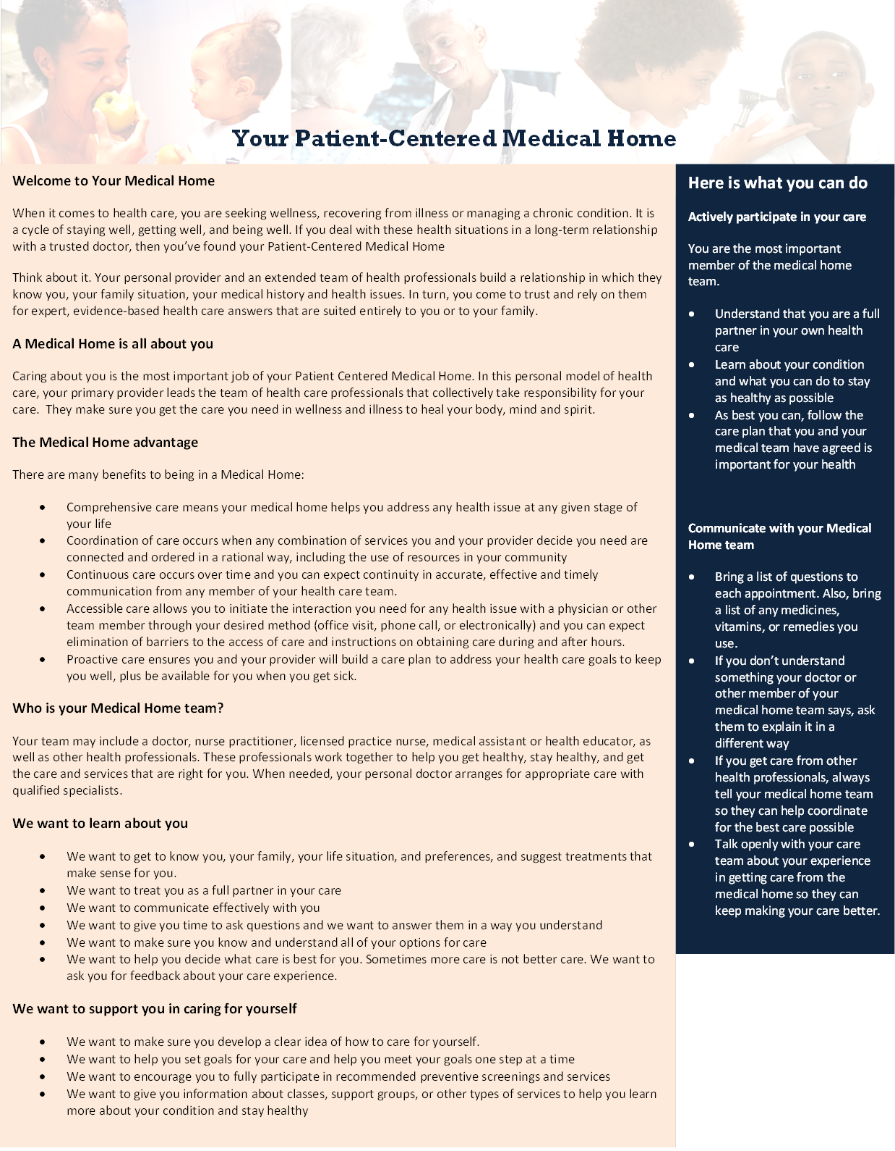

Wickford Family Medicine LLC

John Machata MD

320 Phillips Street Suite 102

North Kingstown, RI 02852

Phone (401) 294-9949

Fax (888) 898-5898

Website <http://wickfordfamilymedicine.weebly.com/>

[Other information: hours, exchange number, etc.]